

Project Submitted to the

**LOVELY PROFESSIONAL UNIVERSITY**

PUNJAB

Submitted by **KOC-35**

**Koventhan M (12217318) Roll no:60**

**Sinan (12222085) Roll no:57**

In the academic year

2022-2023

Under the guidance of

**Sir Naresh**

Department of Computer Science Engineering (INT108)

**ACKNOWLEDGEMENT**

The successful completion of any task would be incomplete without mentioning the name of the faculty who helped to make it possible. We take this opportunity to express my gratitude in few words and respect to all those who helped us in the completion of this project. It is our humble pleasure to acknowledge our deep senses of gratitude to our INT108(Internet Programming) Faculty **Sir Naresh** for his valuable support, constant help and guidance at each and every stage, without which this project would not have come forth. We would also like to thank our friends and our family for encouraging us during the course of this project. Last, but not the least, We would like to thank Department of Computer Science Engineering for giving us the opportunity to undertake this project.

**SOFTWARE & HARDWARE REQUIREMENTS**

**HARDWARE:**

1. Processor – Pentium(R) G2030@ 3.70 GHz
2. RAM: 4 GB
3. System Architecture: 32 or 64 bit Operating system
4. HDD: 500 GB

**SOFTWARE:**

1. Operating system: Linux- Ubuntu 16.04 to 17.10, or Windows 7 to 10
2. Notepad

**ABSTRACT**

The main objective of the HTML Project on Railway Reservation System is to manage the details of Booking, Holiday Packages, Meals, Service, Contact us . It manages all the information about Booking, Holiday Packages, Meals, Service, Contact us . .

**SOURCE CODE**

n=int(input("Enter the Number:"))

#Prime Number Check

flag=0

for i in range(2,n):

if n%i==0:

flag=1

print(i)

break

if flag==1:

print(n,"is not a Prime Number")

else:

print(n,"is a Prime Number")

#Palindrome

x=n

sum=0

while x>0:

r=x%10

sum=sum*10+r

x=x//10

if sum==n:

print(n,"is a Prime Palindrome")

else:

print(n,"is not a Prime Palindrome")

**OUTPUT**

**Prime Palindrome Number**

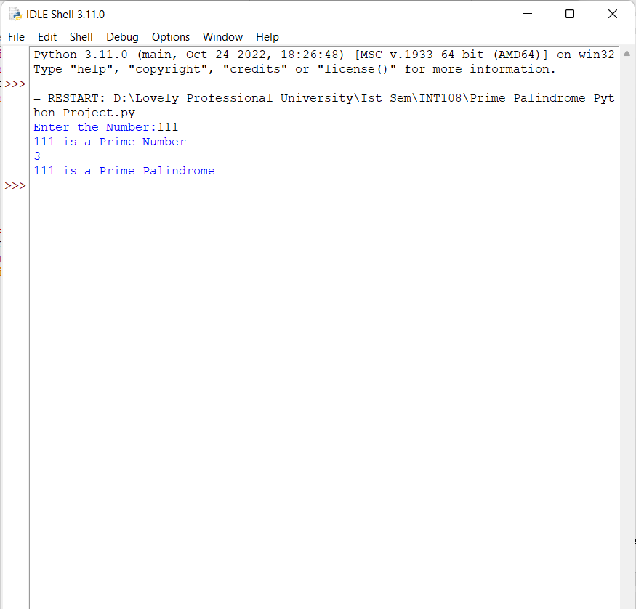

**Not a Prime Palindrome Number**

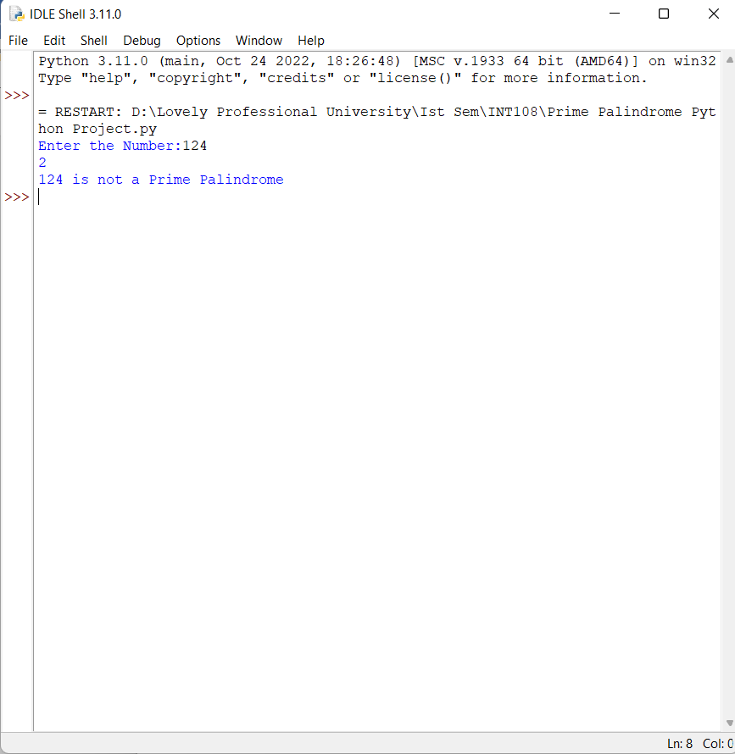

**Conclusion**

Practical Training is a very important part of the curriculum as it strengthens the concepts and enhances knowledge about the practical implementation of all the theory concepts, we have learnt so far in different subjects.

This summer training helped us learn a lot. In this training we did the project on railway reservation system. This project is used to keep a track on reserving the seat to the passenger. It helps managing the system very efficiently and conveniently.

Finally, this gives us a lot of mental satisfaction that the project we have worked upon is a real time project, which will be installed at the customer site after some more session of regress testing.

Although the project work has been done in a complete and detailed manner but due to the constraint of time, we could not include some more features we wanted to. We left these features as a part of the future development. As soon as we’ll get time we’ll try to add them to my project.

**REFERENCES:**

1. Faculty -Mr.Naresh

2. Website: https://www.google.com